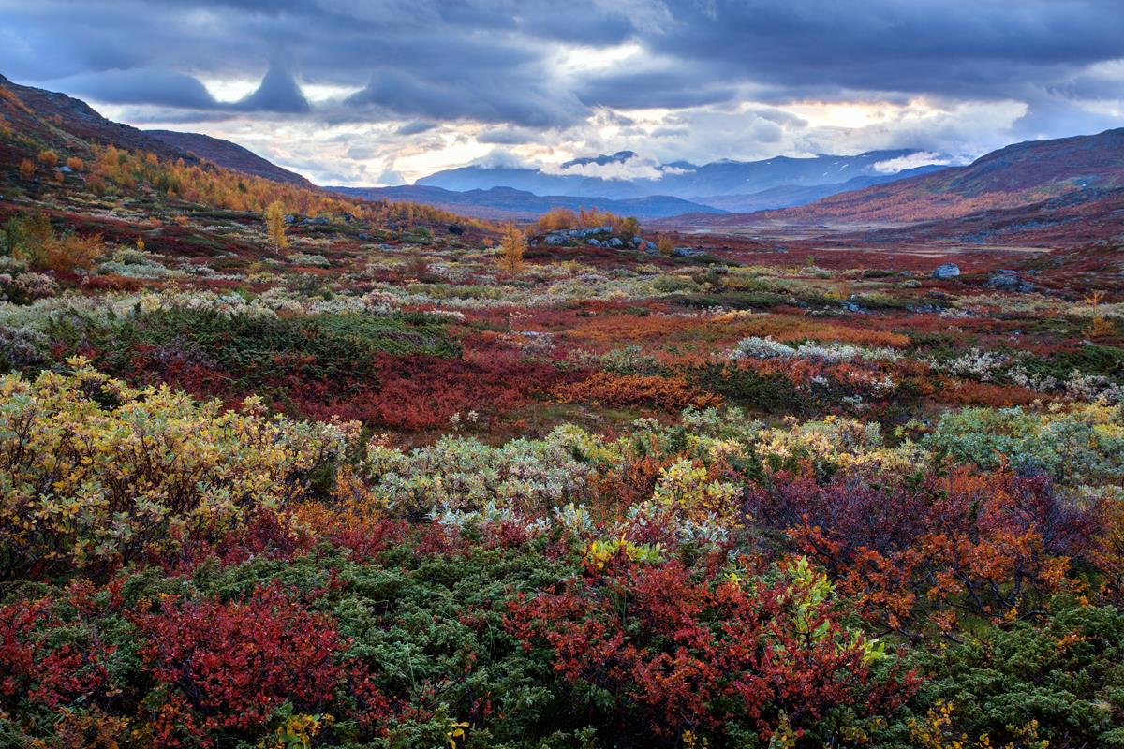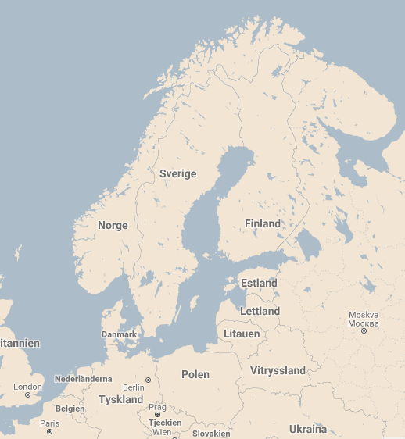**Annual committee meeting Kiruna 2019-06-07—10**

**Conference venue:** Scandic Hotel Ferrum, Kiruna

**Program:**

**June 7**

Arrival in the afternoon, welcome drink and dinner, offered by EFNA

After dinner, enjoy the midnight sun

**June 8**

Morning:

Annual committee meeting, 08.30-12.00

*No arranged program for accompanying persons, own walk/shopping in city*

Afternoon:

Guided tour at the Icehotel 365 in Jukkasjärvi, thereafter

Visit to Nutti Sami Siida, explore the Sami culture, grazing reindeers, etc

Traditional three course dinner in a Sami cot, offered by FSS

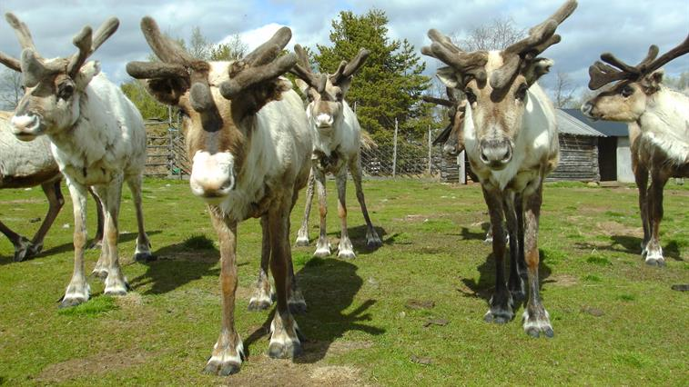

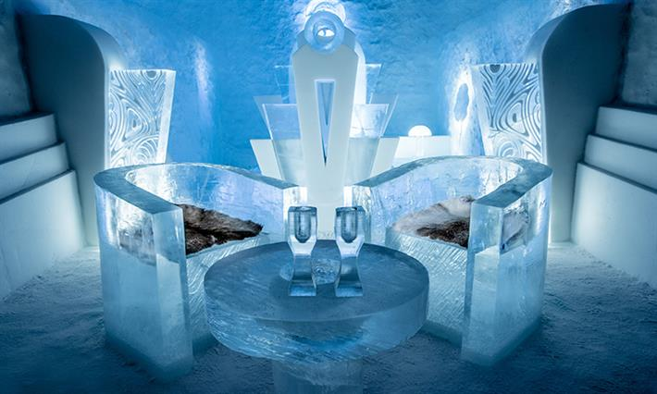

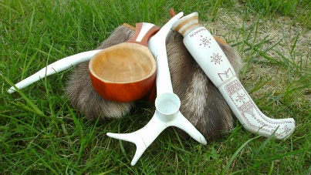

**June 9**

Morning:

Visit to LKAB iron ore mine at level 540 m. We will also learn about moving the oldest parts of Kiruna due to the mining. Some parts are already moved to the new city location.

After lunch we will go for a bus ride to the northwest to Abisko and Torneträsk.

***Please note: For the mine visit and bus ride we must charge you 150 € p.p.***

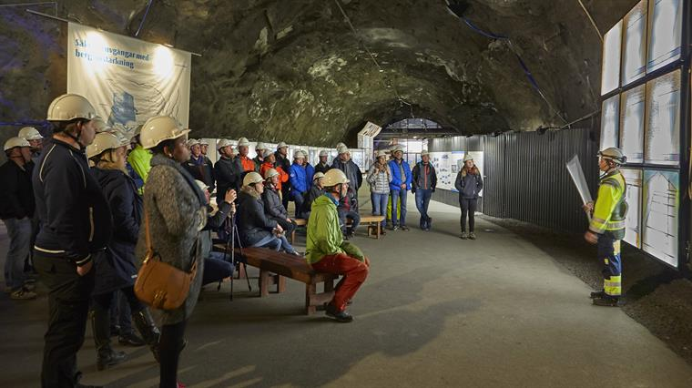

In the evening dinner at own expense.

**June 10**

Farewell and departure.

**Practical information**

* Weather can be unreliable at that time, please bring warm clothes and rain gear in case of bad weather. In the LKAB mine and Icehotel it’s also cold, even in summer time.
* Flights are available from Stockholm Arlanda (ARN) to Kiruna (KRN). SAS and Norwegian are flying this route. Since there are few departures every day, please book flights early.
* We have preliminary bookings at Scandic Hotel Ferrum for June 7-10. Cost for single room is 890 SEK/night and a double room 1090 SEK/night (about 85-105 €/night). You must make your own reservation at [reservation.ferrum@scandichotels.com](mailto:reservation.ferrum@scandichotels.com) with **reservation code SVE070619.** Additional nights have to be booked separately.
* **Registration form** below. Please register before February 28, 2019 by sending the form to [finnvid.prescher@skogsplantor.se](mailto:finnvid.prescher@skogsplantor.se)
* **Payment**, 150 € per person if you want to join the tour on Sunday, please pay in advance not later than May 15, 2019 to:

**IBAN SE39 8000 0821 4990 4115 2142**

**BIC SWEDSESS**

**Swedbank, account holder Föreningen Sveriges Skogsplantproducenter**

**Registration form**

|  |  |  |
| --- | --- | --- |
|  | Delegate | Partner |
| First name | Hannes |  |
| Surname | Gadermair |  |
| Title | Mag. |  |
| Organization or company | Verband österreichischer Forstbaumschulen |  |
| Address | Untersunzing 7, 4962 Mining |  |
| Country | Austria |  |
| Email | [office@forstbaumschulen.or.at](mailto:office@forstbaumschulen.or.at) |  |
| Mobile phone | +43 664 2426232 |  |
| Special requirements (dietary) |  |  |
| Day and time of arrival | Fr. 7th June |  |
| Day and time of departure | Mo 10th June |  |
| Extra accompanying persons, name |  | |

|  |  |  |  |  |  |
| --- | --- | --- | --- | --- | --- |
| **Meals**  (welcome reception on Friday) | **Date** | **Delegate** | | **Partner** | |
| Lunch | Dinner | Lunch | Dinner |
| Friday June 7 |  |  |  |  |
| Saturday June 8 |  |  |  |  |
| Sunday June 9 |  |  |  |  |
| **Program & Visits** |  | **Delegate** | | **Partner** | |
| Saturday June 8 | Meeting  Visit Jukkasjärvi | | Visit Jukkasjärvi | |
| Sunday June 9 | Visit LKAB mine & Bus tour, cost 150 € | | Visit LKAB mine & bus tour, cost 150 € | |
| Extra accompanying persons | Visit Jukkasjärvi, no ……… | | Visit LKAB mine & bus tour, no ……… cost 150 €/person | |

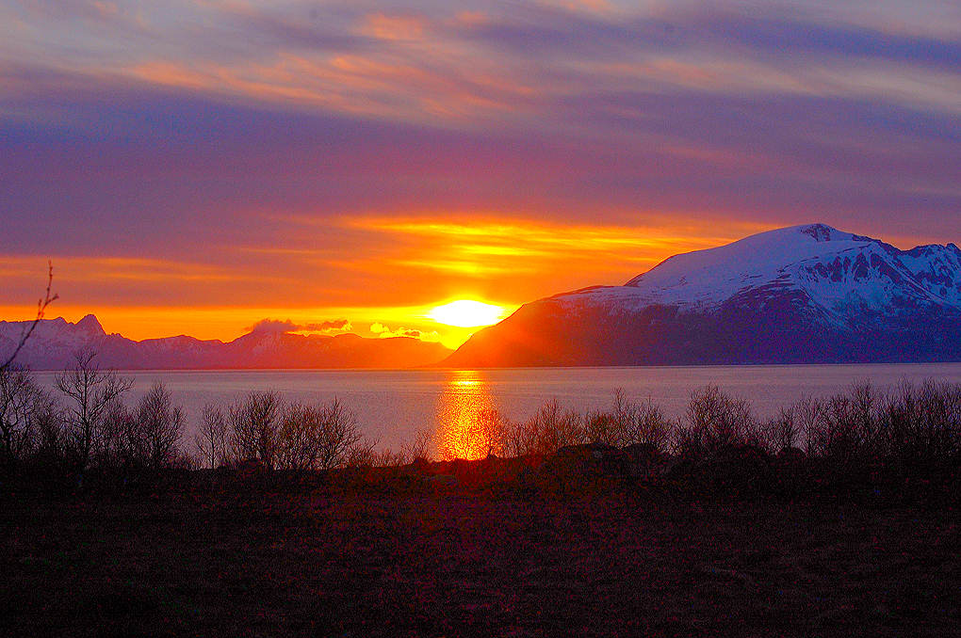

**Welcome to Kiruna!**

**Max, Oskar and Finnvid**